Name: Anushka Pachpute
Class : S.Y.B.Sc Data Science
Practical: DataBase Management System Practical
Semester : III
Date : 07/10/2026

Q.1) Answer the following tables

CREATE DATABASE CollegePune_DB;
USE CollegePune_DB;
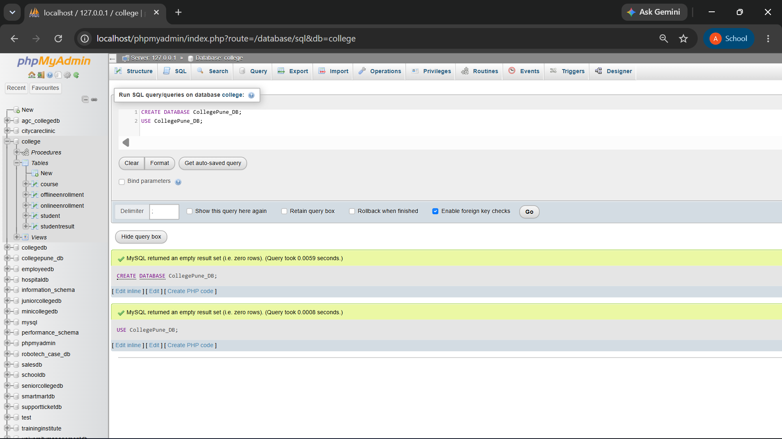
CREATE TABLE COURSE (
Course_ID INT PRIMARY KEY,
Course_Name VARCHAR(50),
Fees DECIMAL(10,2)
);

CREATE TABLE STUDENT (
Student_ID INT PRIMARY KEY,
Student_Name VARCHAR(50),
Course_ID INT,
Marks INT
);

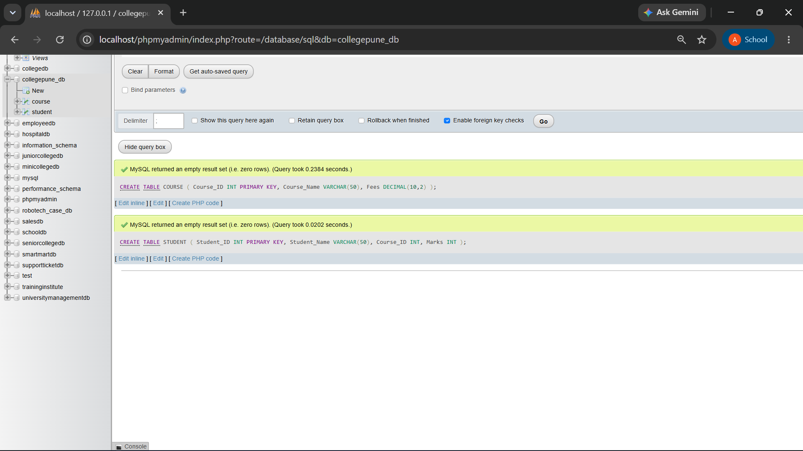

Q.1) Write SQL queries to:

- Create the student table with student_id as primary key
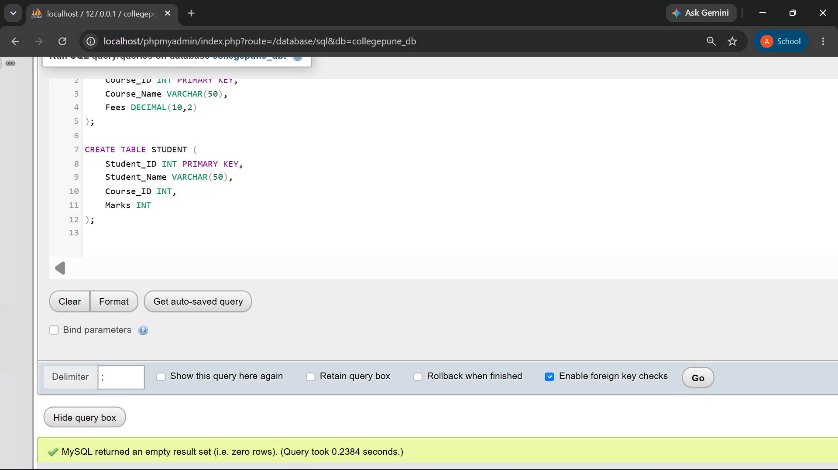

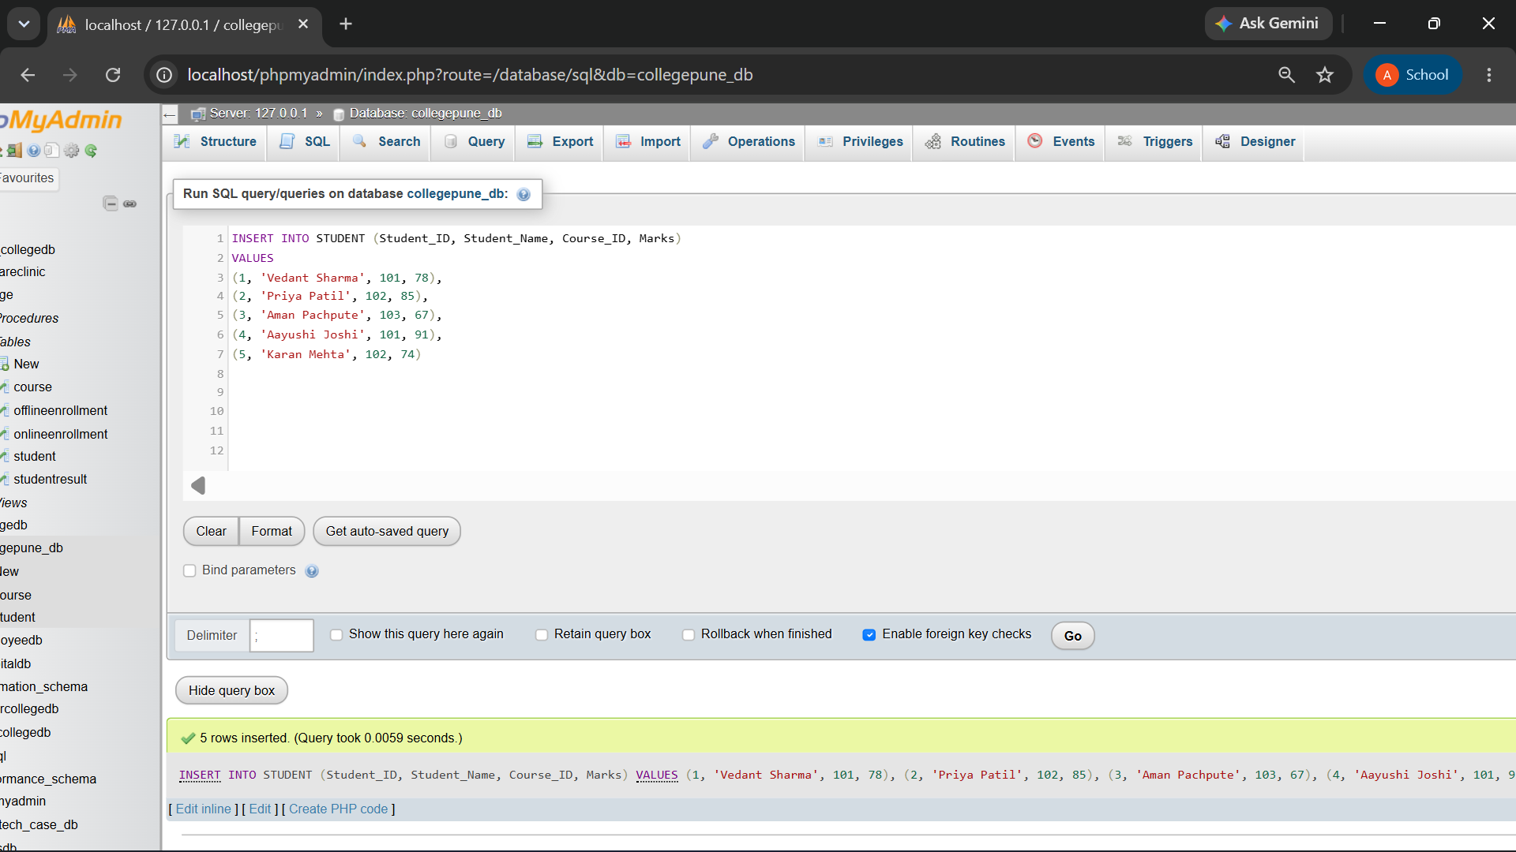
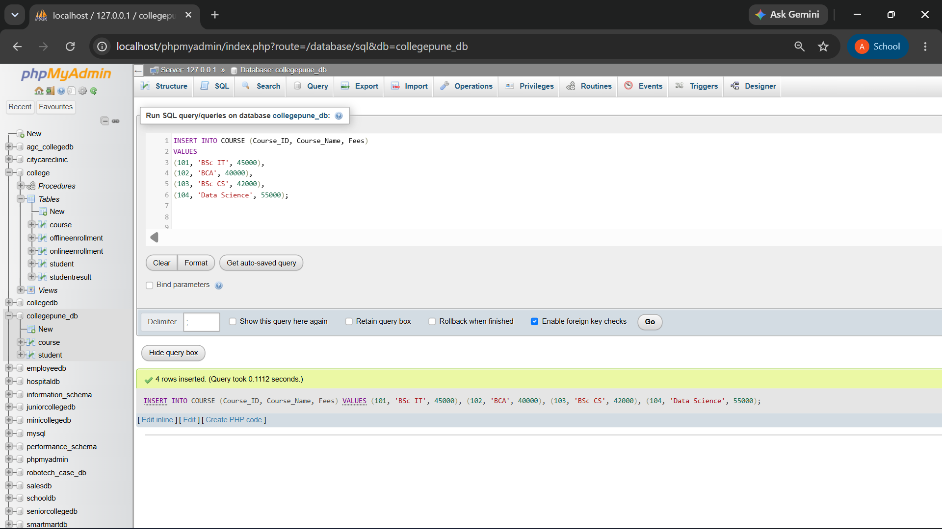

- Display students who have scored more than 70 marks
SELECT * FROM STUDENT
WHERE Marks > 70;
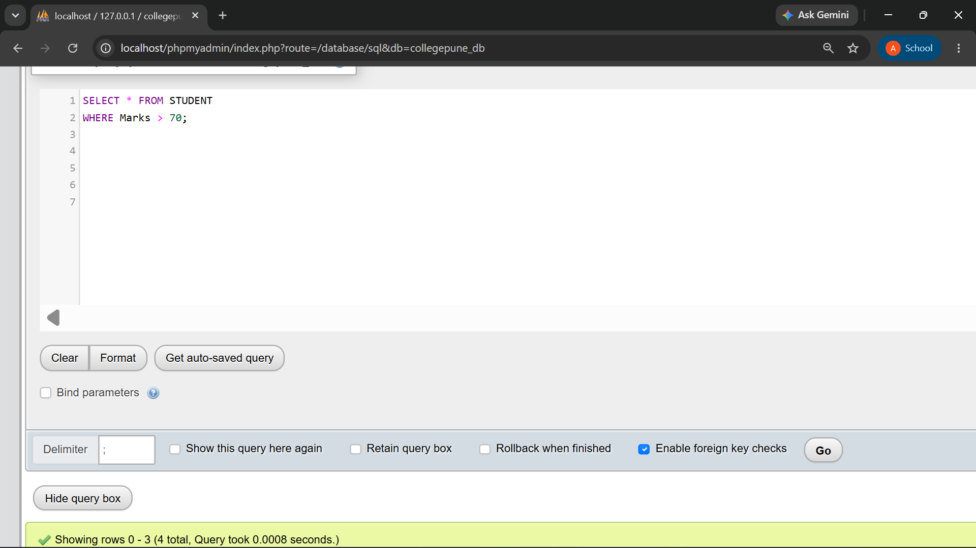
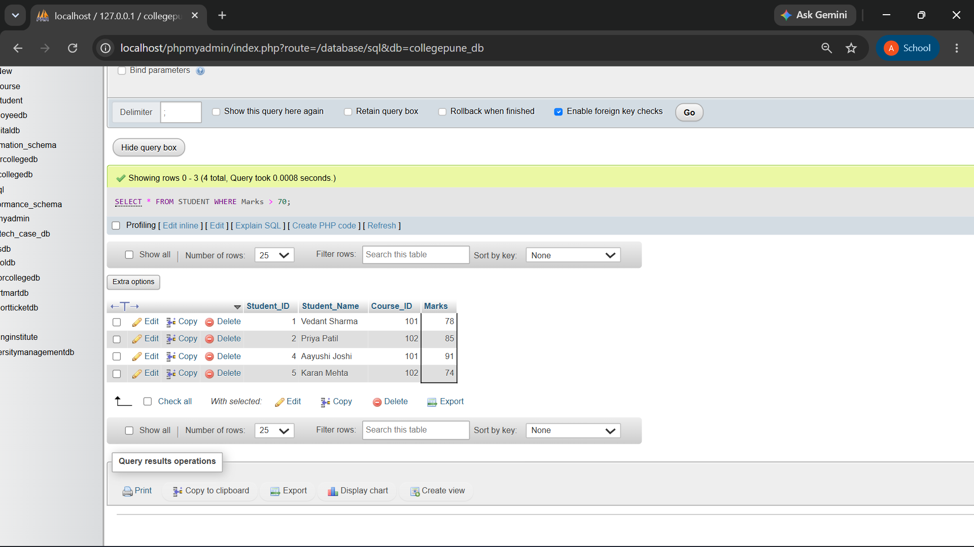

- Display student names with corresponding course names

SELECT S.Student_Name, C.Course_Name
FROM STUDENT S
INNER JOIN COURSE C
ON S.Course_ID = C.Course_ID;
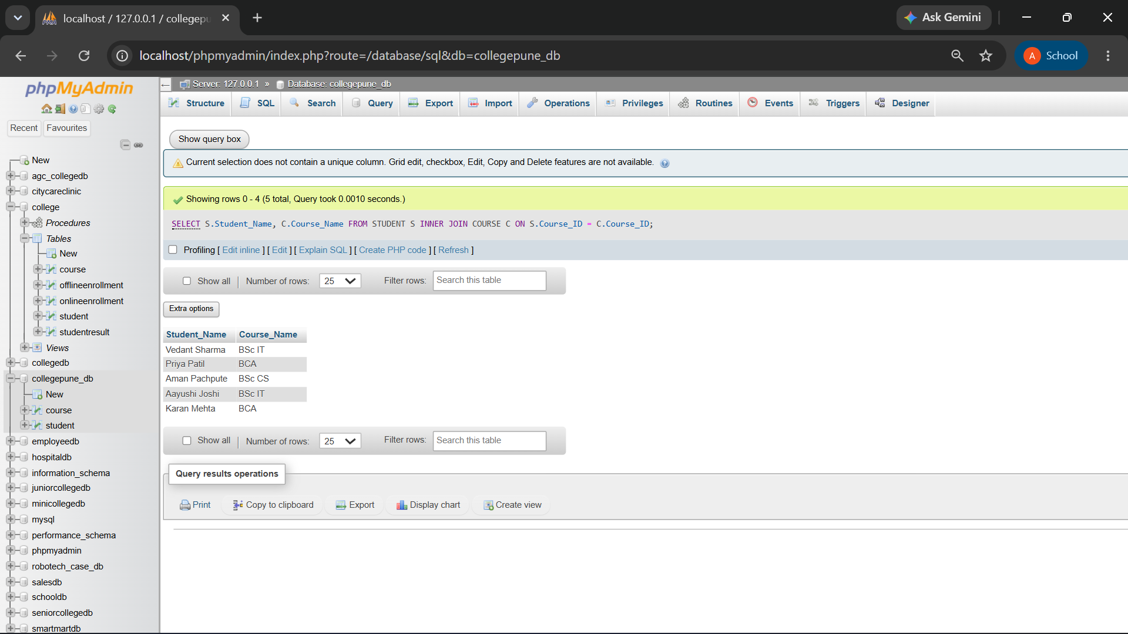

- Find average marks for each Course_ID
SELECT Course_ID, AVG(Marks) AS AverageMarks
FROM STUDENT
GROUP BY Course_ID;

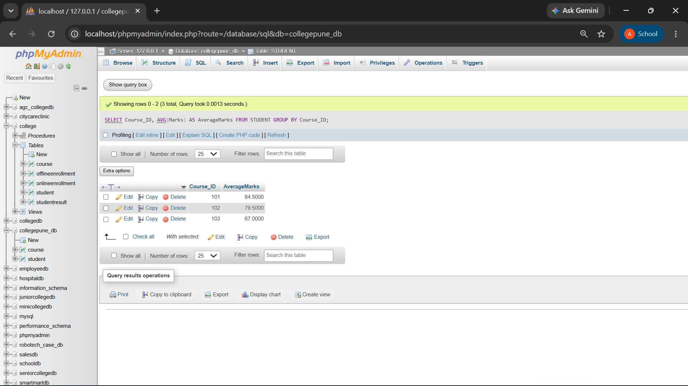

E) Display courses whose average marks are greater than 65

SELECT Course_ID, AVG(Marks) AS AverageMarks
FROM STUDENT
GROUP BY Course_ID
HAVING AVG(Marks) > 65;

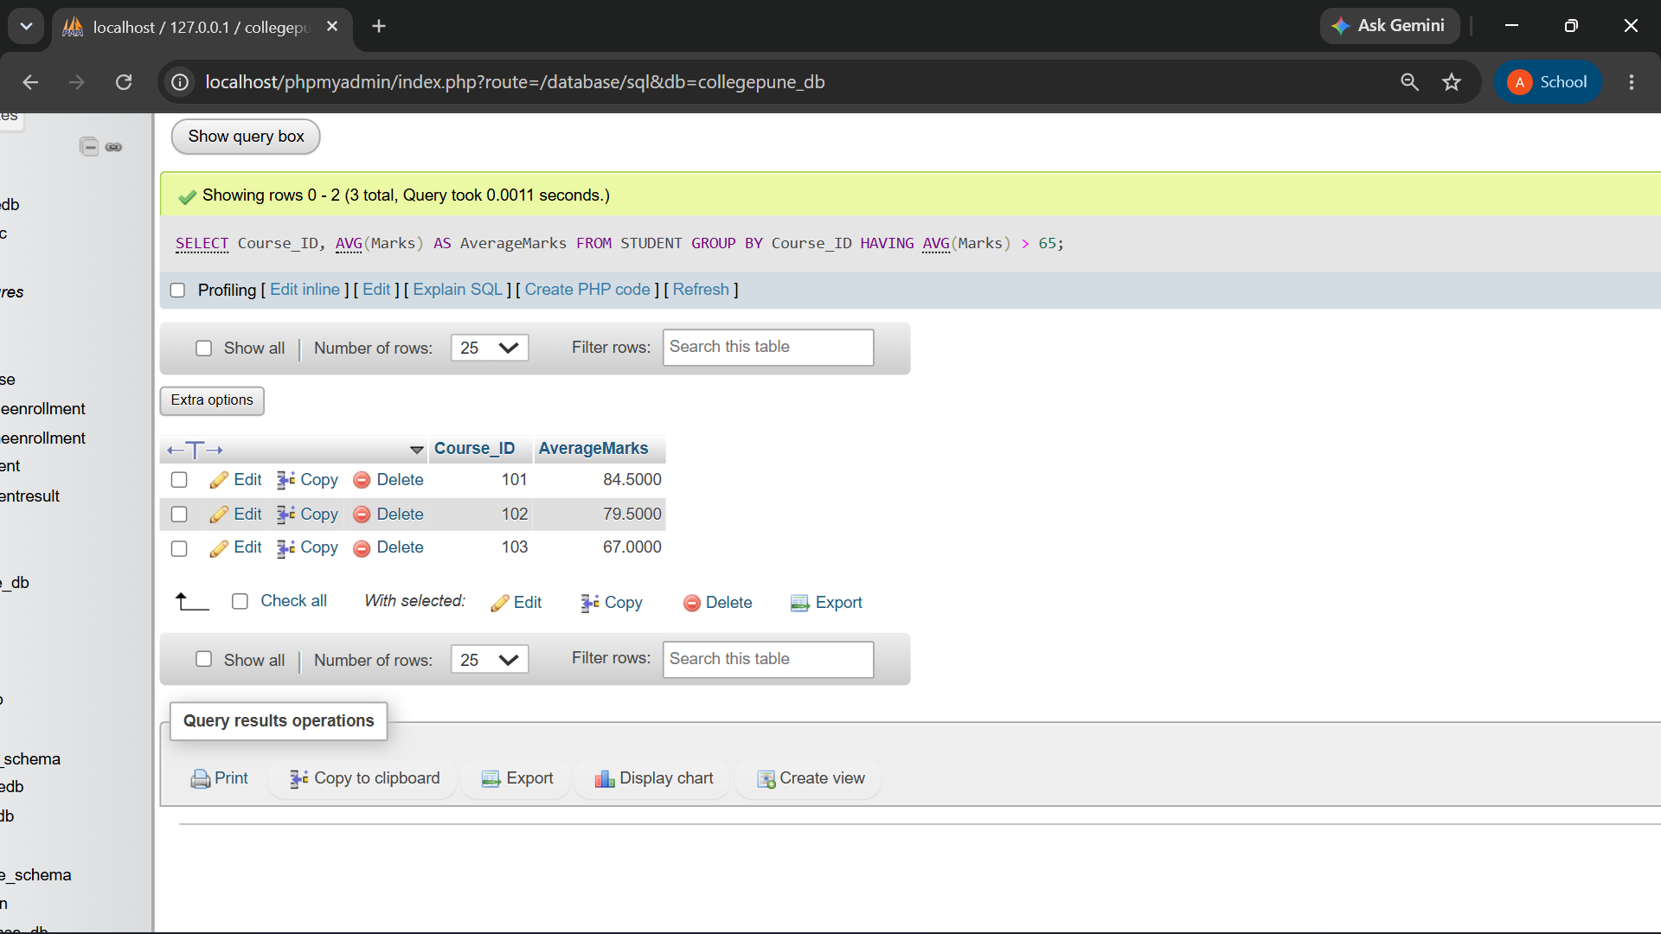

Q.2) Consider the Table

CREATE DATABASE EmployeePune_DB;
USE EmployeePune_DB;
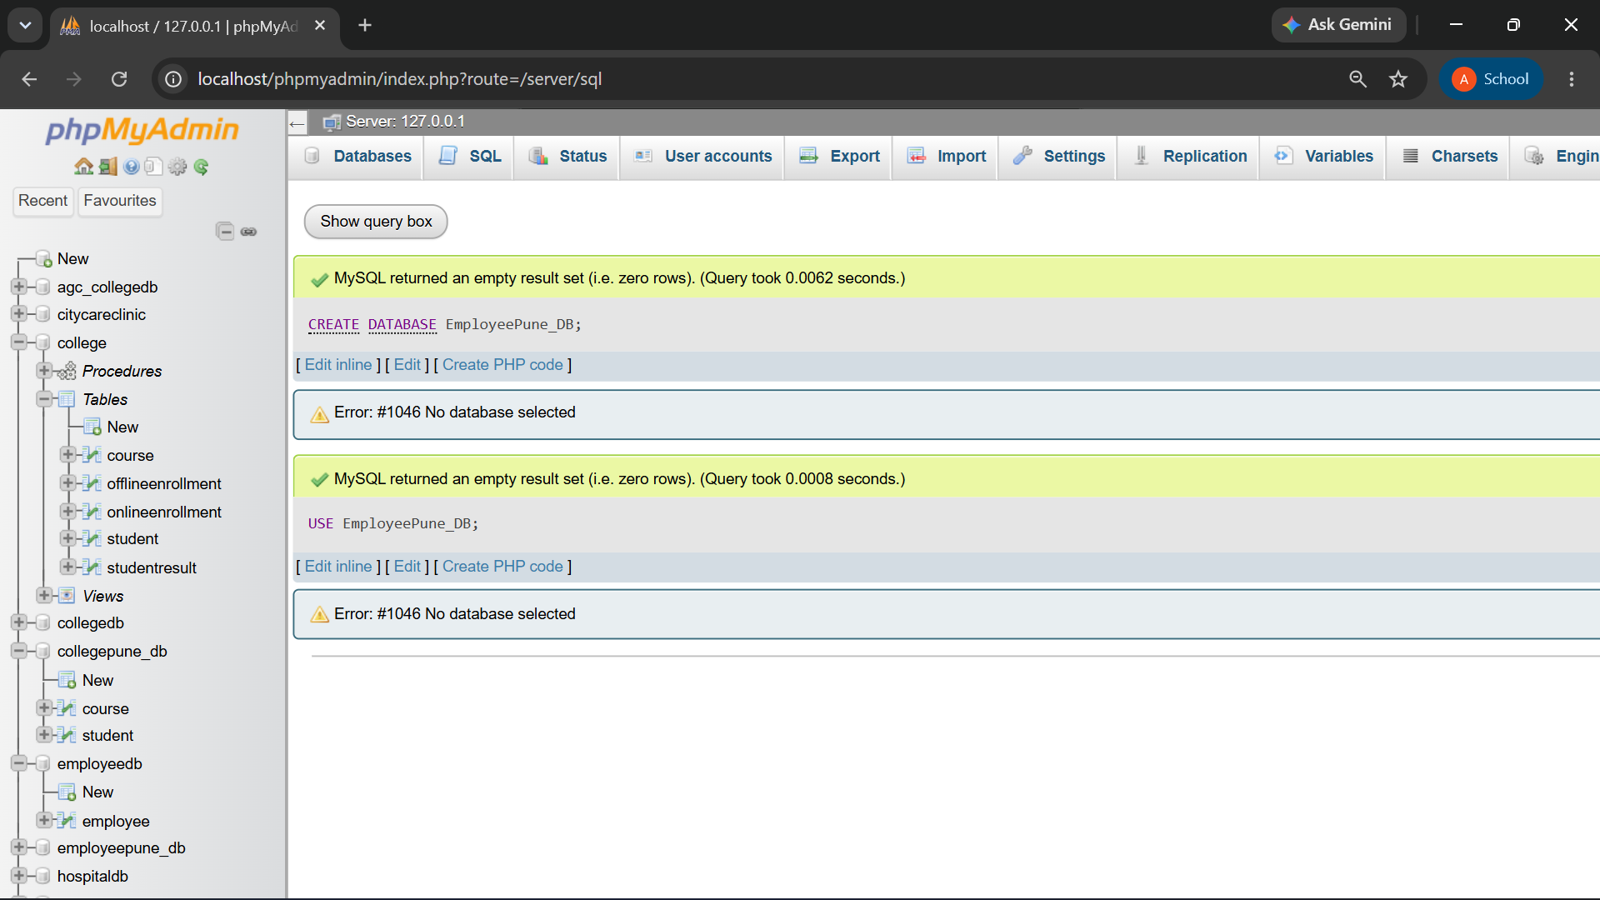
CREATE TABLE EMPLOYEE (
Emp_ID INT PRIMARY KEY,
Emp_Name VARCHAR(50),
Department VARCHAR(30),
Salary DECIMAL(10,2),
Joining_Date DATE
);

INSERT INTO EMPLOYEE
(Emp_ID, Emp_Name, Department, Salary, Joining_Date)
VALUES
(1, 'Babita Sharma', 'IT', 55000, '2023-01-10'),
(2, 'Priya Patil', 'HR', 45000, '2022-05-15'),
(3, 'Rakesh Kumar', 'IT', 65000, '2021-07-20'),
(4, 'Avanee Joshi', 'Finance', 50000, '2023-03-12'),
(5, 'Karan Wahi', 'IT', 60000, '2022-08-10')
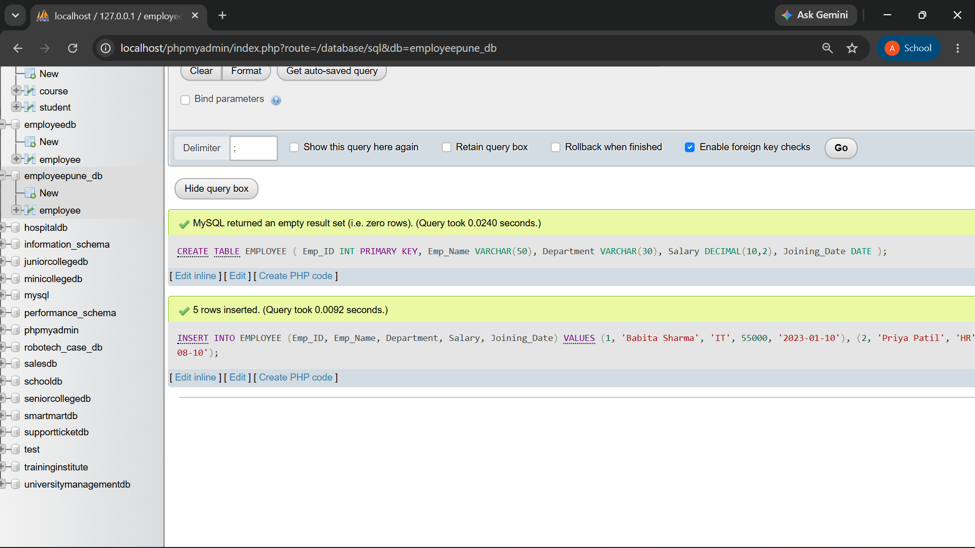

- ) IT employees in descending order of salary
SELECT * FROM EMPLOYEE
WHERE Department = 'IT'
ORDER BY Salary DESC;

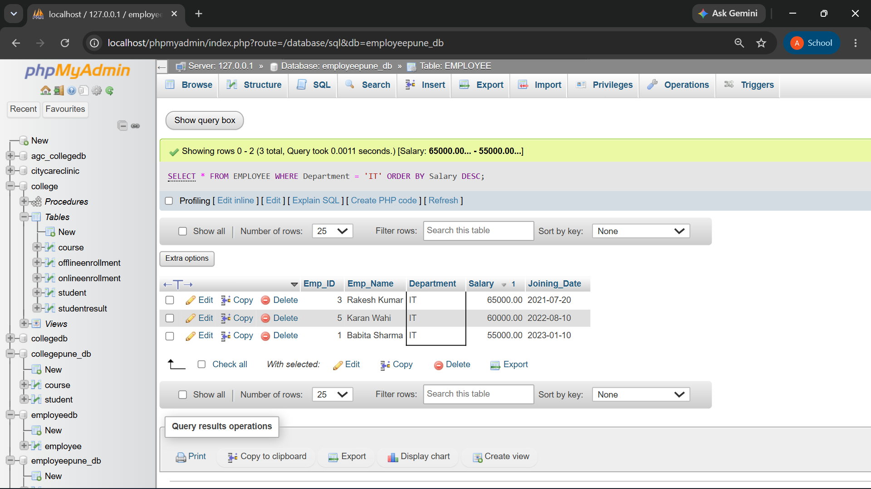

b) Display the highest salary

SELECT MAX(Salary) AS HighestSalary
FROM EMPLOYEE;
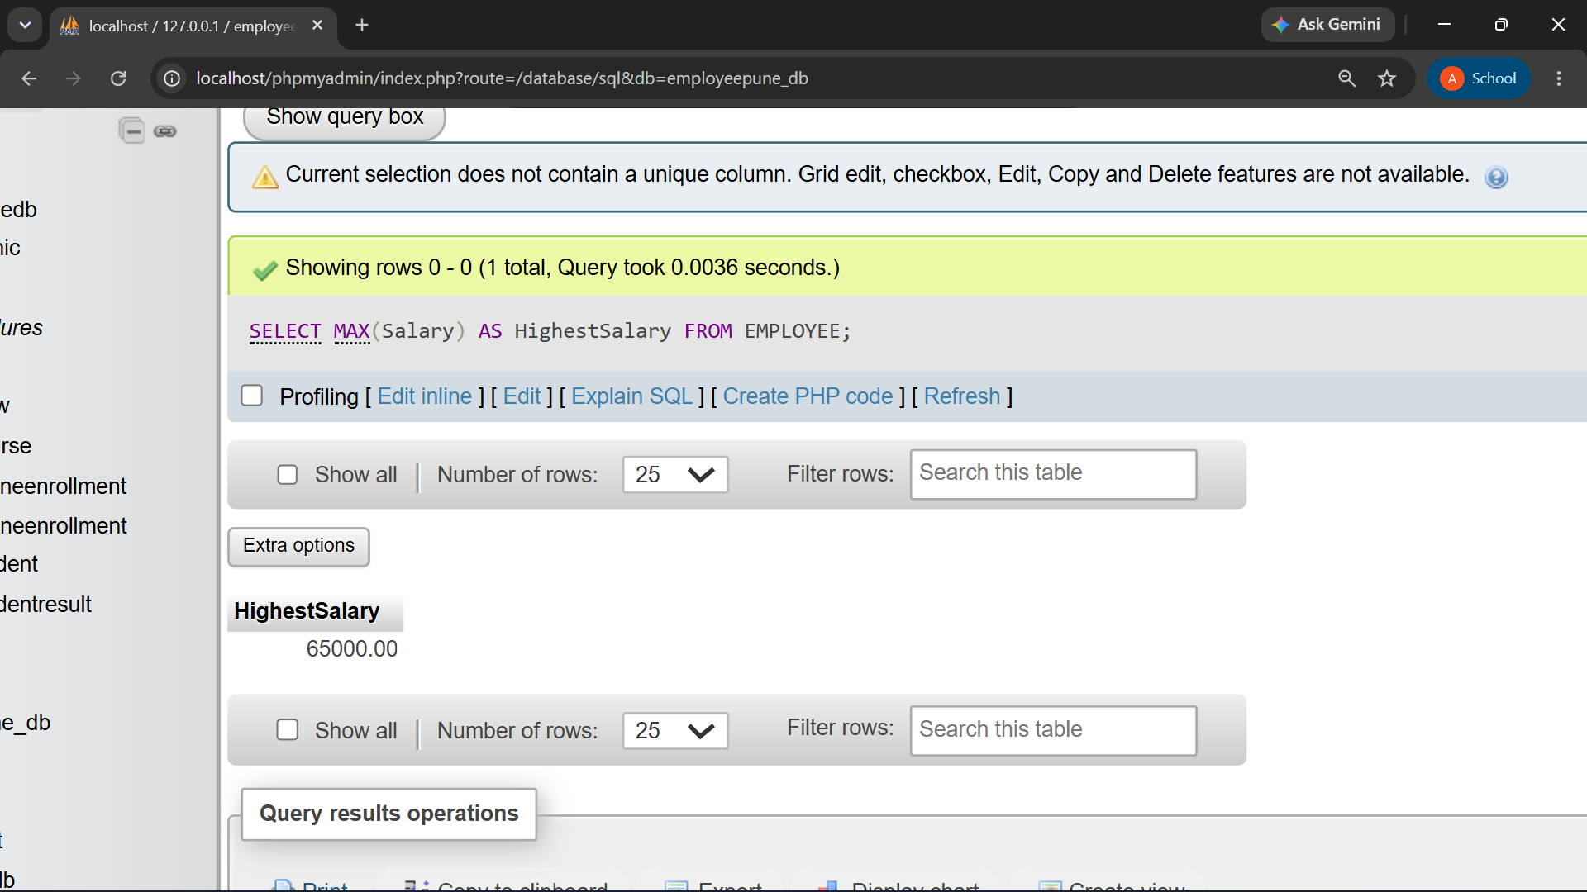
c) Departments having more than 3 employees

SELECT Department, COUNT(*) AS TotalEmployees
FROM EMPLOYEE
GROUP BY Department
HAVING COUNT(*) > 3;
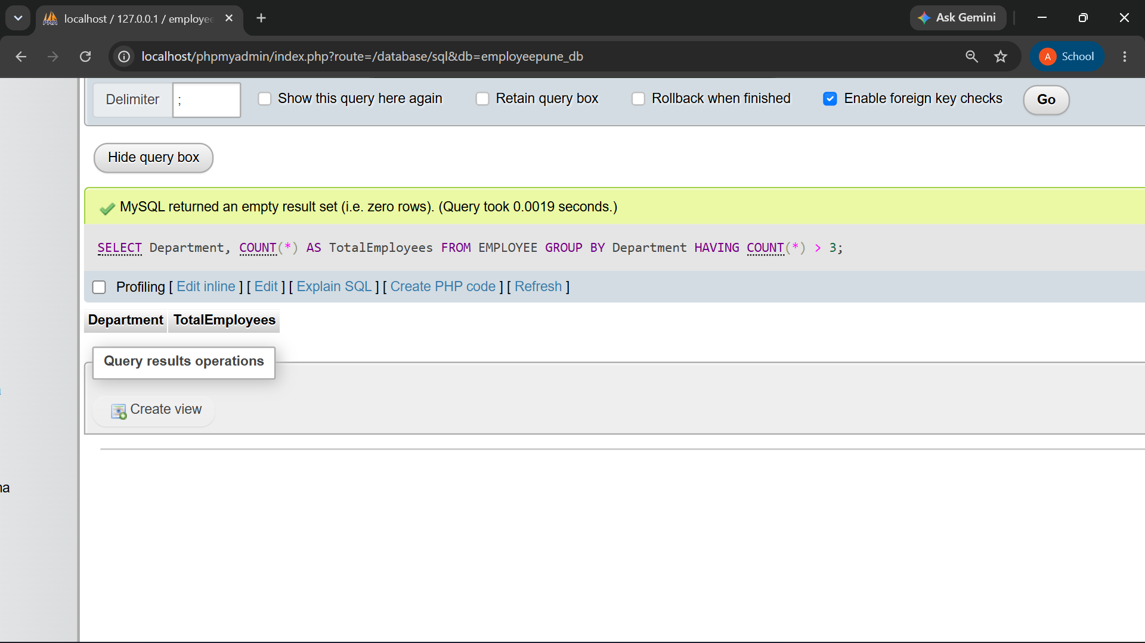
d) Employees whose salary is greater than average salary
SELECT * FROM EMPLOYEE
WHERE Salary > (
SELECT AVG(Salary)
FROM EMPLOYEE
);
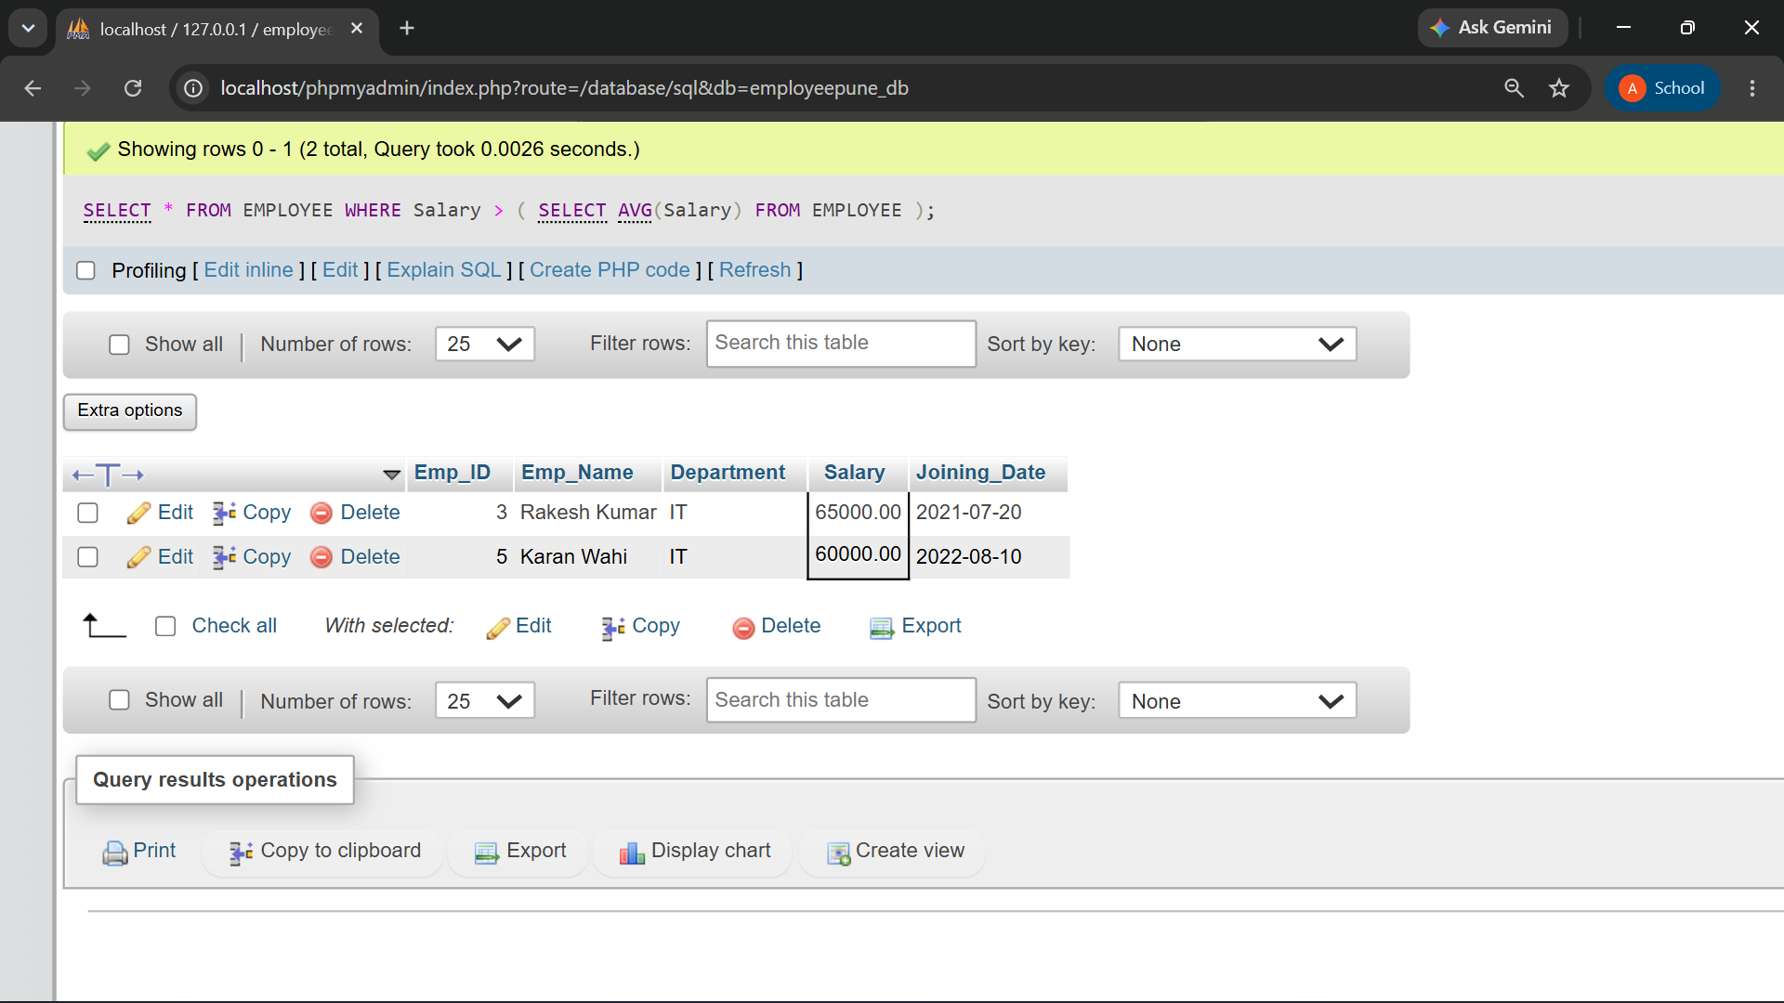

- Create a view names IT_Employees containing employees belonging to the IT department

CREATE VIEW IT_Employees AS
SELECT * FROM EMPLOYEE
WHERE Department = 'IT';

SELECT * FROM IT_ Employees;
